

Practical File



**Sachin Rajbhar**

**COURSE: BCA**

**ROLL NO:41221139**

**DATA & FILE STRUCTURE USING C**

**FACULTY**

**Mrs. DIVYA RANA**

|  |  |  |
| --- | --- | --- |
| S.NO | P R A C T I C A L S | SIGN. |
| 1 | Write a program to initialize array at Compile time. |  |
| 2 | Write a program to initialize array at Run time. |  |
| 3 | Write a program to print the elements of array in reverse order. |  |
| 4 | Write a program to read marks of 5 students and calculate sum & average using array. |  |
| 5 | Write a program for Transversal in array. |  |
| 6 | Write a program for Bound checking in array. |  |
| 7 | Write a program for Insertion of element at a specific location in array. |  |
| 8 | Write a program for Insertion of element at the beginning of the array. |  |
| 9 | Write a program for Insertion of element at the end of the array. |  |
| 10 | Write a program for Deletion of element at a specific location in array. |  |
| 11 | Write a program for Deletion of element at the beginning of the array. |  |
| 12 | Write a program for Deletion of element at the end of the array. |  |
| 13 | Write a program to initialize 2-D array at run time. |  |
| 14 | Write a program to print 2-D array matrix and calculate the sum of its elements. |  |
| 15 | Write a program for insertion in 3-D array. |  |
| 16 | Write a program for addition of two matrix. |  |
| 17 | Write a program for multiplication of two matrix. |  |
| 18 | Write a program for Linear Search. |  |
| 19 | Write a program for Binary Search. |  |
| 20 | Write a program for Bubble Sort. |  |
| 21 | Write a program for Selection Sort. |  |
| 22 | Write a program for Insertion Sort. |  |
| 23 | Write a program for Merge Sort. |  |
| 24 | Write a program for Quick sort. |  |
| 25 | Write a program for |  |
| 26 | Write a program for |  |
| 27 | Write a program for |  |
| 28 | Write a program for |  |
| 29 | Write a program for |  |
| 30 | Write a program for |  |

**PRACTICAL-1**

**AIM:** Write a program to **initialize array at Compile time**.

**PROGRAM:**

//initializing the size of array in different ways.

//1st way

#include<stdio.h>

int main(){

    int arr[5]={1,2,3,4,5};

    int i;

    for(i=0;i<5;i++){

        printf("\t%d",arr[i]);

    }

    return 0;

}

//2nd way

#include<stdio.h>

int main(){

    int arr[2+3]={1,2,3,4,5};

    int i;

    for(i=0;i<5;i++){

        printf("\t%d",arr[i]);

    }

    return 0;

}

//3rd way

#include<stdio.h>

int main(){

    int arr[10/2]={1,2,3,4,5};

    int i;

    for(i=0;i<5;i++){

        printf("\t%d",arr[i]);

    }

    return 0;

}

**OUTPUT:**

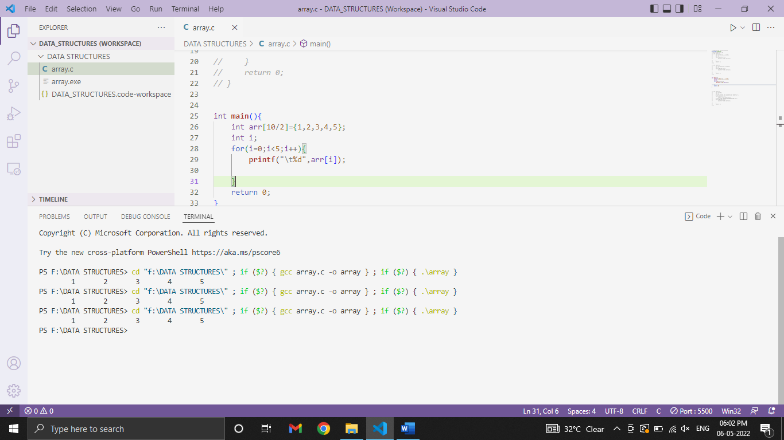

**PRACTICAL-2**

**AIM:** Write a program to **initialize array at Run time**.

**PROGRAM:**

#include<stdio.h>

int main(){

    int arr[5];

    int i;

    printf("ENTER THE ELEMENTS OF ARRAY\n");

    for(i=0;i<5;i++){

        scanf("\t%d",&arr[i]);}

    printf("THE ENTERED ELEMENTS ARE:\n");

    for(i=0;i<5;i++){

        printf("\n%d",arr[i]);

    }

    return 0;

}

**OUTPUT:**

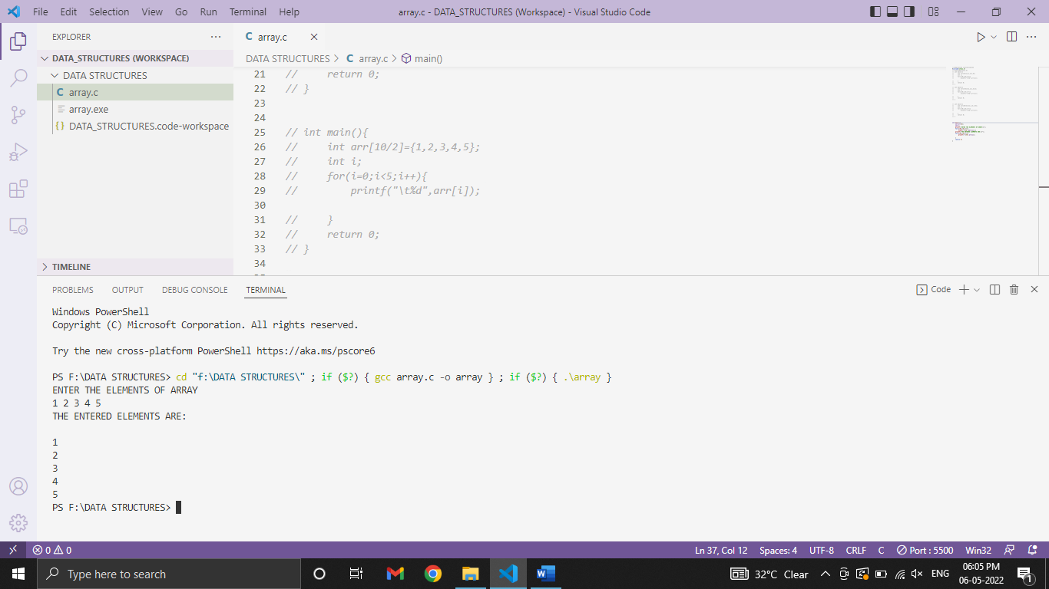

**PRACTICAL-3**

**AIM:** Write a program to print the elements of **array in reverse** order.

**PROGRAM:**

#include<stdio.h>

int main(){

    int arr[5];

    int i;

    printf("Enter the elements of array:\n");

    for(i=0;i<5;i++){

        scanf("%d",&arr[i]);

    }

    printf("Entered elements are:\n");

    for(i=4;i>=0;i--){

        printf("%d\t",arr[i]);

    }

  return 0;

}

**OUTPUT:**

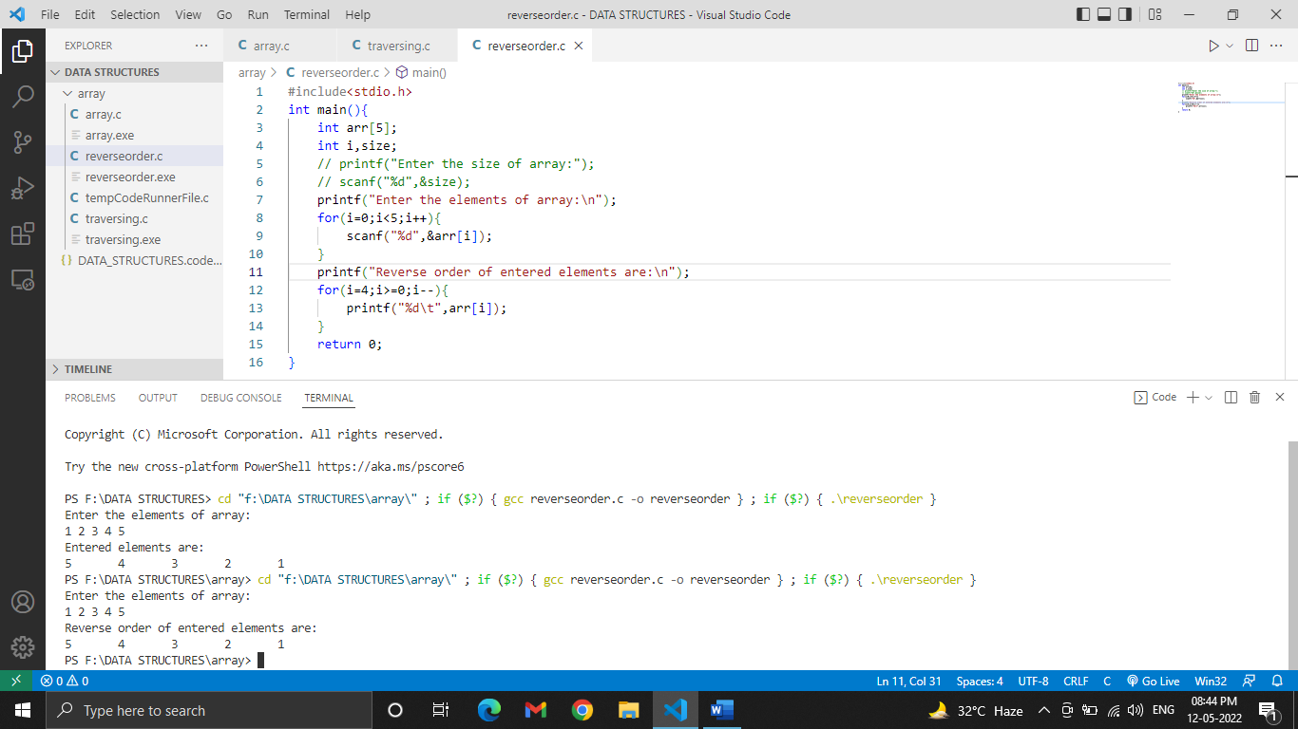

**PRACTICAL-4**

**AIM:** Write a program to read marks of 5 students and calculate sum & average using array.

**PROGRAM:**

#include<stdio.h>

int main(){

    int marks[5];

    int i,sum=0;

    float avg;

        printf("Enter the marks  of 5 subjects\n");

    for(i=0;i<5;i++){

        scanf("%d",&marks[i]);

    }

        for(i=0;i<5;i++){

            sum = sum + marks[i];

        }

            printf("\nSUM=%d",sum);

        avg = sum/5;

        printf("AVERAGE =%f",avg);

return 0;

}

**OUTPUT:**

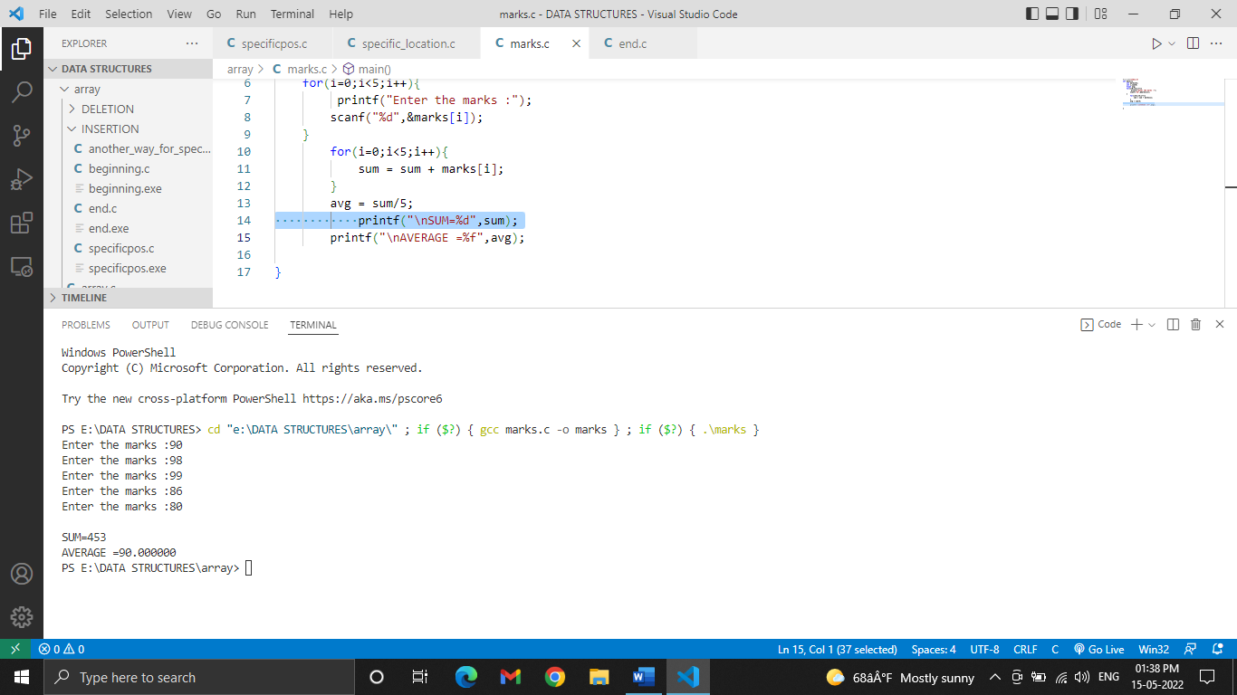

**PRACTICAL-5**

**AIM:** Write a program for **Transversal** in array.

**PROGRAM:**

#include<stdio.h>

int main(){

    int arr[50];

    int i,size;

    printf("Enter the size of array:");

    scanf("%d",&size);

    printf("Enter the elements of array:\n");

    for(i=0;i<size;i++){

        scanf("%d",&arr[i]);

    }

    printf("Entered elements are:\n");

    for(i=0;i<size;i++){

        printf("%d\t",arr[i]);

    }

return 0;

}

**OUTPUT:**

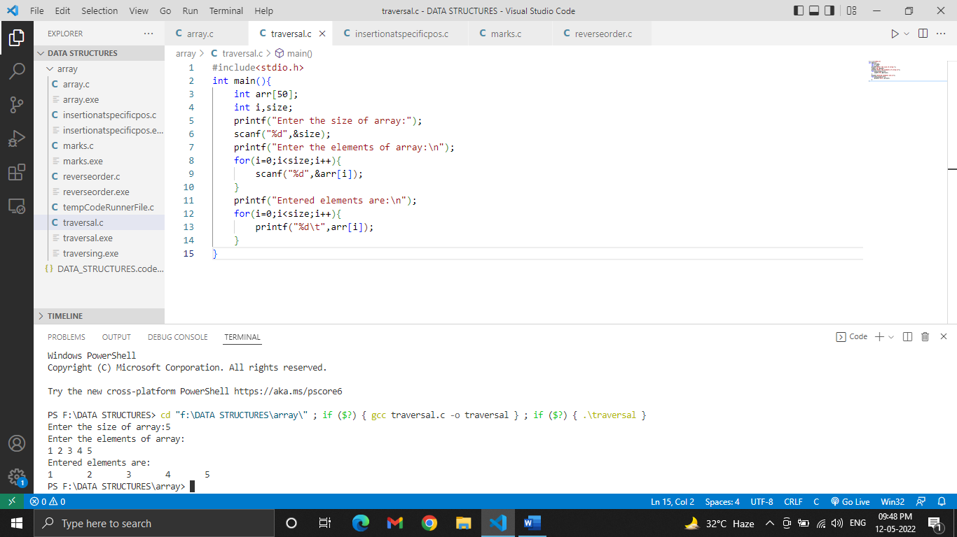

**PRACTICAL-6**

**AIM:** Write a program for **Bound checking** in array.

**PROGRAM:**

#include<stdio.h>

int main(){

    int arr[10];

    int i,size;

    printf("Enter the size of array:");

    scanf("%d",&size);

    if(size<0||size>10){

        printf("Invalid size");

    }

    else{

        printf("Enter the elements of array:\n");

    for(i=0;i<size;i++){

        scanf("%d",&arr[i]);

       }

    printf("\nEntered elements are:\n");

    for(i=0;i<size;i++){

        printf("%d\t",arr[i]);

    }

}

return 0;

}

**OUTPUT:**

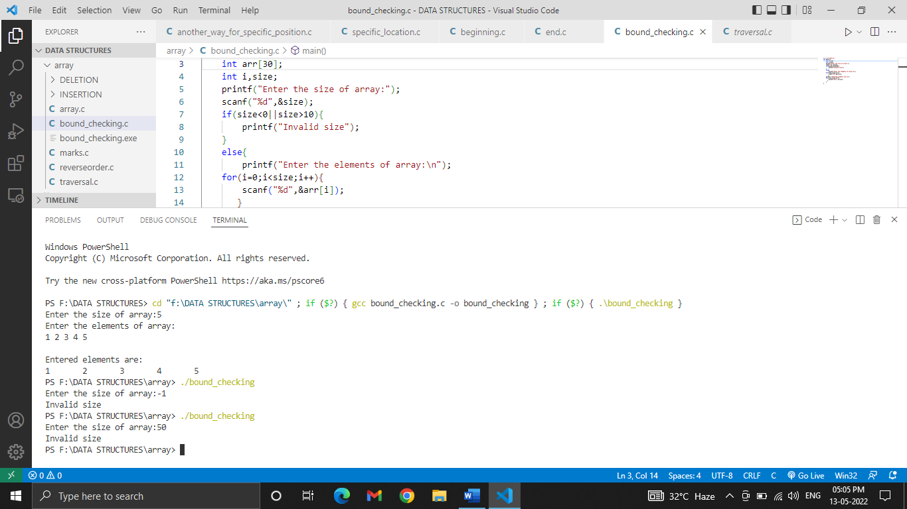

**PRACTICAL-7**

**AIM:** Write a program for Insertion of element **at a specific location** in array.

**PROGRAM:**

#include<stdio.h>

int main(){

    int a[50];

    int i,size,num,pos;

    printf("Enter the size of array:");

    scanf("%d",&size);

    printf("Enter the elements of array:\n");

    for(i=0;i<size;i++){

        scanf("%d",&a[i]);

    }

    printf("Enter the position where you want to insert the element:");

    scanf("%d",&pos);

     printf("Enter the element at that position:");

    scanf("%d",&num);

    if(pos<=0||pos>=size+1){

        printf("Invalid position");}

        else{

            for(i=size-1;i>=pos-1;i--){

                a[i+1]=a[i];

            }

            a[pos-1]=num;

            size++;

        }

    printf("Array after inserting the new element:\n");

    for(i=0;i<size;i++){

        printf("%d\t",a[i]);

}

return 0;

}

**OUTPUT:**

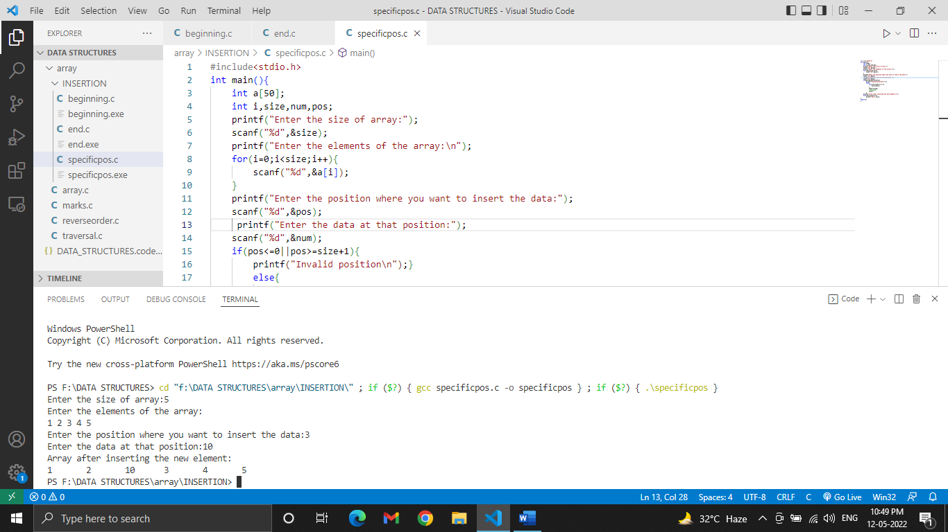

**PRACTICAL-8**

**AIM:** Write a program for Insertion of element **at the beginning** of the array.

**PROGRAM:**

#include<stdio.h>

int main(){

    int a[50];

    int i,size,num;

    printf("Enter the size of array:");

    scanf("%d",&size);

    printf("Enter the elements of array:\n");

    for(i=0;i<size;i++){

        scanf("%d",&a[i]);

    }

    printf("Enter the element to insert at that position a[0]:");

    scanf("%d",&num);

            for(i=size-1;i>=0;i--){

                a[i+1]=a[i];

            }

            a[0]=num;

            size++;

    printf("Array after inserting the new element:\n");

    for(i=0;i<size;i++){

        printf("%d\t",a[i]);

}

return 0;

}

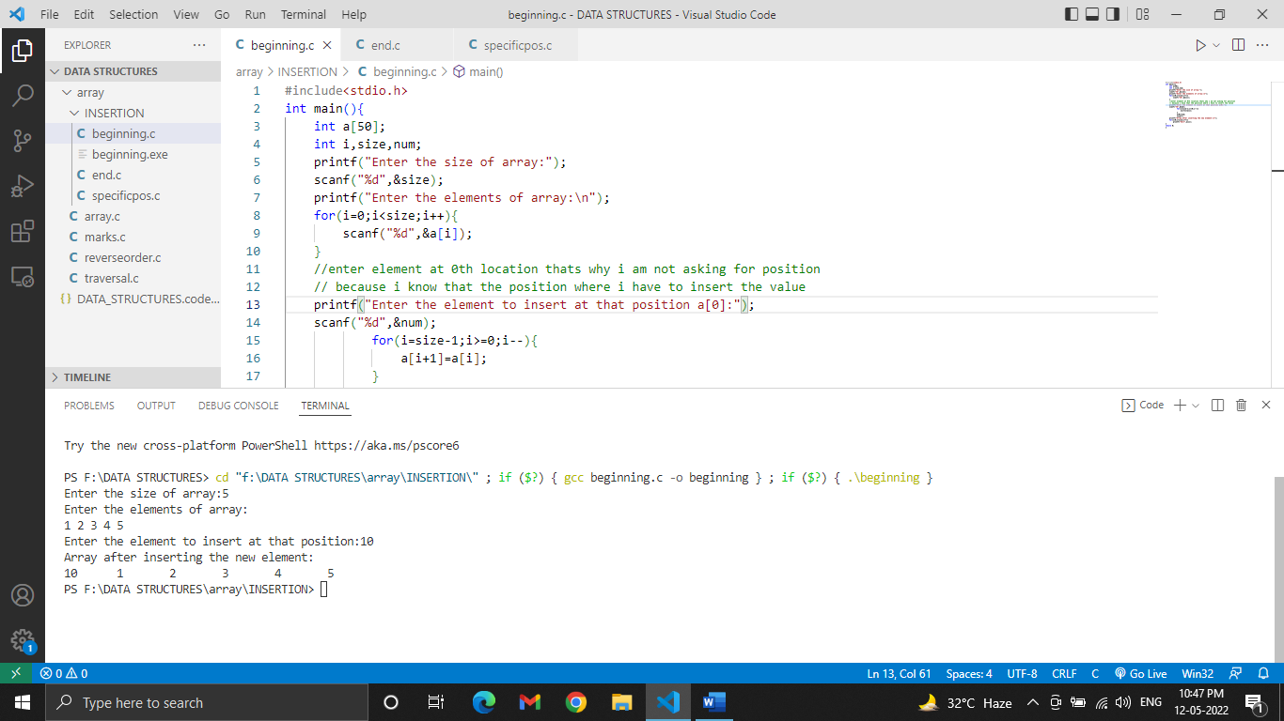**OUTPUT:**

**PRACTICAL-9**

**AIM:** Write a program for Insertion of element **at the end** of the array.

**PROGRAM:**

#include<stdio.h>

int main(){

    int a[50];

    int i,size,num;

    printf("Enter the size of array:");

    scanf("%d",&size);

    printf("Enter the elements of array:\n");

    for(i=0;i<size;i++){

        scanf("%d",&a[i]);

    }

     printf("Enter the element to insert at that position:");

    scanf("%d",&num);

            a[5]=num;

            size++;

    printf("Array after inserting the new element:\n");

    for(i=0;i<size;i++){

        printf("%d\t",a[i]);

}

return 0;

}

**OUTPUT:**

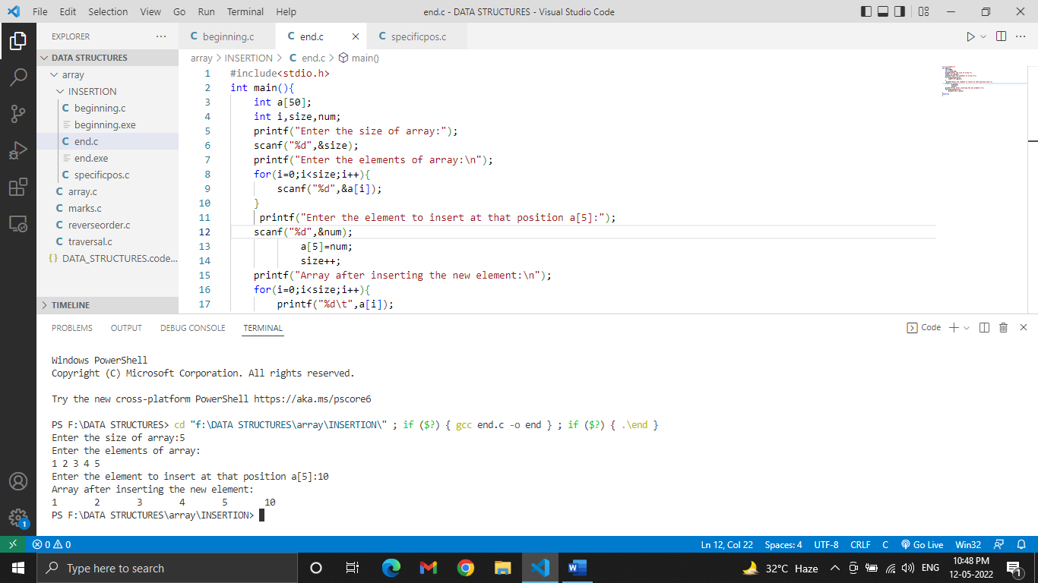

**PRACTICAL-10**

**AIM:** Write a program for deletion of element **at a specific location** of the array.

**PROGRAM:**

#include<stdio.h>

int main(){

    int a[50];

    int i,size,num,pos;

    printf("Enter the size of array:");

    scanf("%d",&size);

    printf("Enter the elements of the array:\n");

    for(i=0;i<size;i++){

        scanf("%d",&a[i]);

    }

    printf("Enter the position from where you want to delete data:");

    scanf("%d",&pos);

    if(pos<0||pos>size){

        printf("Invalid position\n");}

        else{

            for(i=pos-1;i<size-1;i++){

                a[i]=a[i+1];

            }

            size--;

        }

    printf("Array after deleting the element:\n");

    for(i=0;i<size;i++){

        printf("%d\t",a[i]);

}

return 0;

}

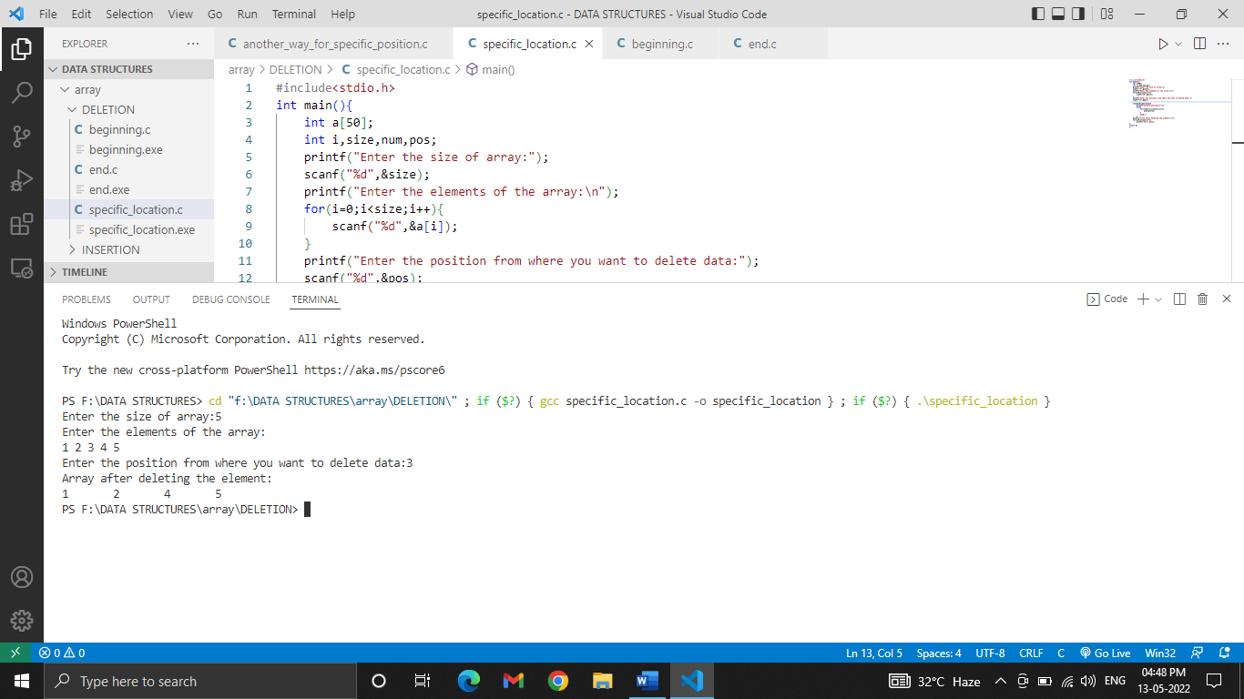**OUTPUT:**

**PRACTICAL-11**

**AIM:** Write a program for deletion of element **at the beginning** of the array.

**PROGRAM:**

#include<stdio.h>

int main(){

    int a[50];

    int i,size,num,pos;

    printf("Enter the size of array:");

    scanf("%d",&size);

    printf("Enter the elements of the array:\n");

    for(i=0;i<size;i++)

        scanf("%d",&a[i]);

            for(i=0;i<size-1;i++){

                a[i]=a[i+1];

            }

            size--;

    printf("Array after deleting the element:\n");

    for(i=0;i<size;i++){

        printf("%d\t",a[i]);

}

return 0;

}

**OUTPUT:**

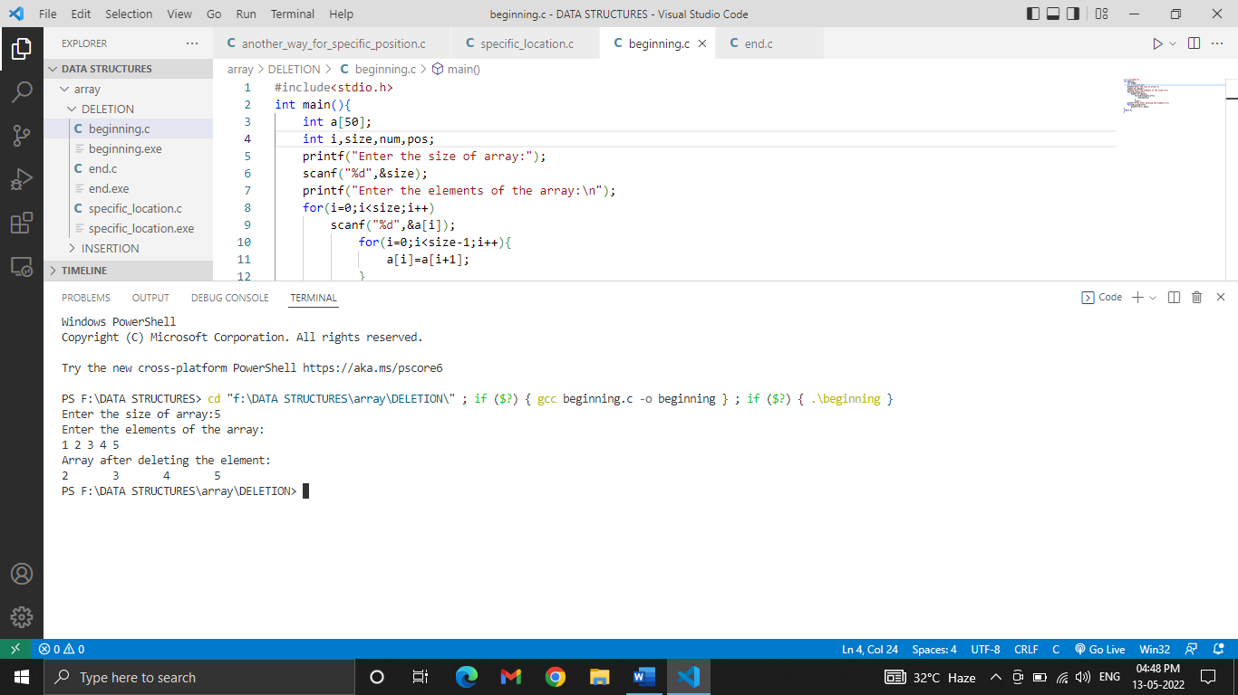

**PRACTICAL-12**

**AIM:** Write a program for deletion of element **at the end** of the array.

**PROGRAM:**

#include<stdio.h>

int main(){

    int a[50];

    int i,size,num,pos,item;

    printf("Enter the size of array:");

    scanf("%d",&size);

    printf("Enter the elements of the array:\n");

    for(i=0;i<size;i++){

        scanf("%d",&a[i]);

    }

            size--;

            printf("\n%d\n",item);

    printf("Array after deleting the element:\n");

    for(i=0;i<size;i++){

        printf("%d\t",a[i]);

}

return 0;

}

**OUTPUT:**

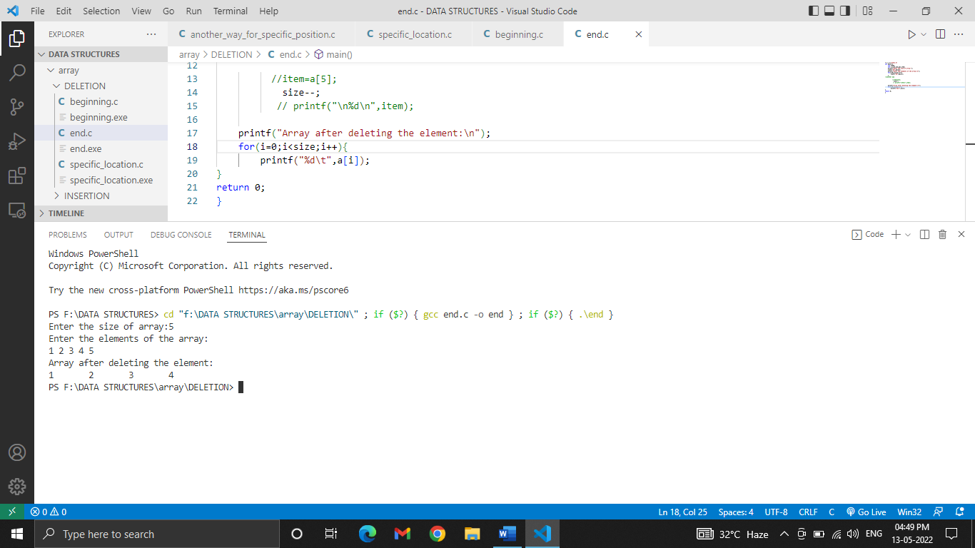

**PRACTICAL-13**

**AIM:** Write a program to initialize 2-D array at run time.

**PROGRAM:**

#include<stdio.h>

int main(){

    int i,j;

    int  arr[2][3];

    printf("Enter the elements:\n");

    for(i=0;i<2;i++){

        for(j=0;j<3;j++){

        scanf("%d",&arr[i][j]);

    }

    }

     printf("The resultant Matrix is:\n");

     for(i=0;i<2;i++){

        for(j=0;j<3;j++){

        printf("%d ",arr[i][j]);

        }

        printf("\n");

     }

}

**OUTPUT:**

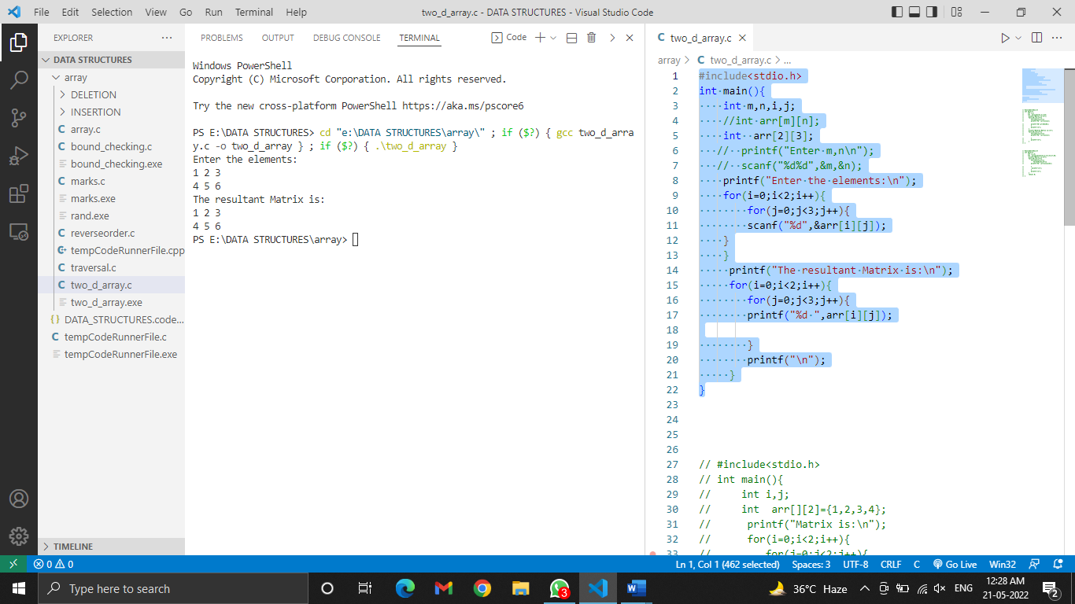

**PRACTICAL-14**

**AIM:** Write a program to print 2-D array matrix and calculate the sum of its elements.

**PROGRAM:**

#include<stdio.h>

int main(){

    int m,n,i,j;

    int sum=0;

    int  arr[2][3];

    printf("Enter the elements:\n");

    for(i=0;i<2;i++){

        for(j=0;j<3;j++){

        scanf("%d",&arr[i][j]);

    }

    }

    printf("The matrix is:\n");

    for(i=0;i<2;i++){

        for(j=0;j<3;j++){

        printf("%d\t",arr[i][j]);

    }

    printf("\n");

    }

    for(i=0;i<2;i++){

        for(j=0;j<3;j++){

            sum+=arr[i][j];

        }

    }

     printf("The sum of the elements of the Matrix is: %d\n",sum);

}

**OUTPUT:**

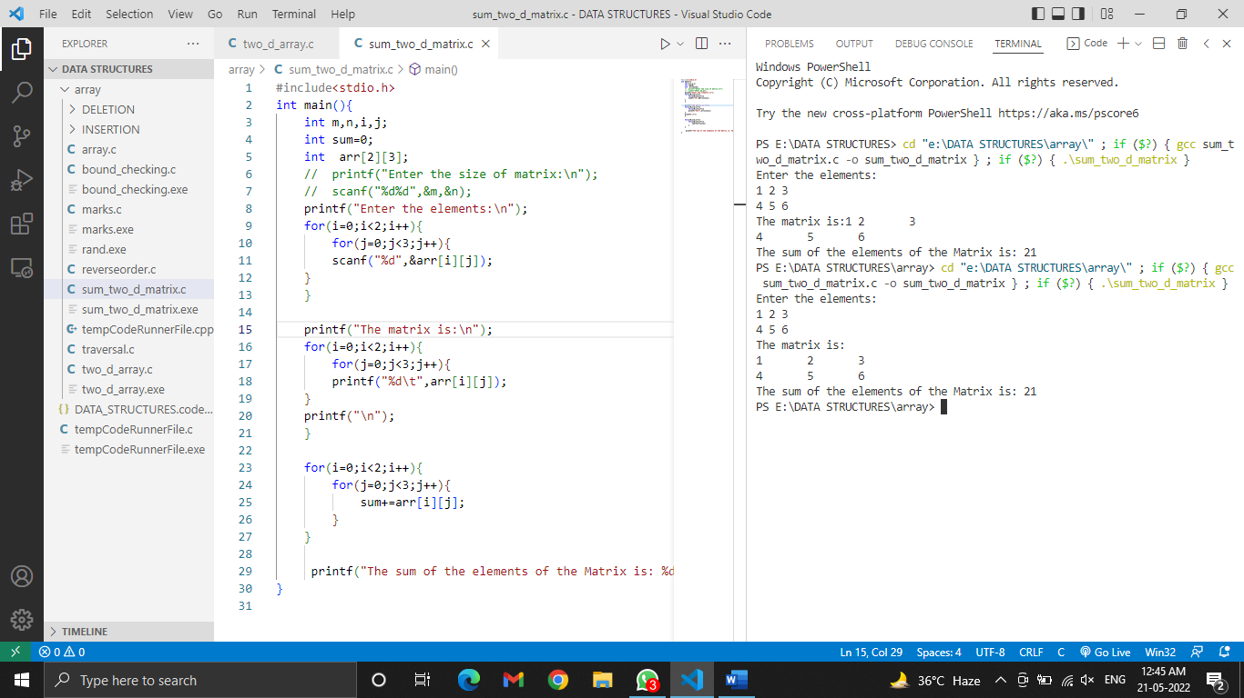

**PRACTICAL-15**

**AIM:** Write a program for insertion in 3-D array.

**PROGRAM:**

#include<stdio.h>

//insertion in 3-D

int main(){

    int i,j,k;

    int a[2][2][2];

printf("Enter elements of matrix\n");

for(i=0;i<2;i++){

    for(j=0;j<2;j++){

            for(k=0;k<2;k++){

        scanf("%d",&a[i][j][k]);

    }

}

}

printf("Resultant of matrix\n");

for(i=0;i<2;i++){

    printf("Block %d:\n",i+1);

    for(j=0;j<2;j++){

            for(k=0;k<2;k++){

        printf("%d ",a[i][j][k]);

    }

    printf("\n");

}

}

return 0;

}

**OUTPUT:**

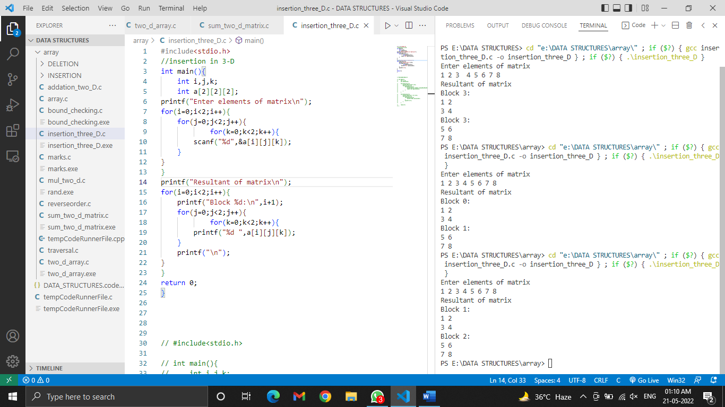

**PRACTICAL-16**

**AIM:** Write a program for addition of two matrix.

**PROGRAM:**

#include <stdio.h>

int main()

{

int a[2][2],b[2][2],sum[2][2];

int i,j;

printf("Enter elements of 1st matrix\n");

for(i=0;i<2;i++){

    for(j=0;j<2;j++){

        scanf("%d",&a[i][j]);

    }

}

printf("Enter elements of 2nd matrix\n");

for(i=0;i<2;i++){

    for(j=0;j<2;j++){

        scanf("%d",&b[i][j]);

    }

}

for(i=0;i<2;i++){

    for(j=0;j<2;j++){

            sum[i][j]=a[i][j]+b[i][j];

    }

}

printf("Result of the matrix\n");

    for(i=0;i<2;i++){

for(j=0;j<2;j++){

           printf("%d ",sum[i][j]);

    }

    printf("\n");

}

return 0;

}

**OUTPUT:**

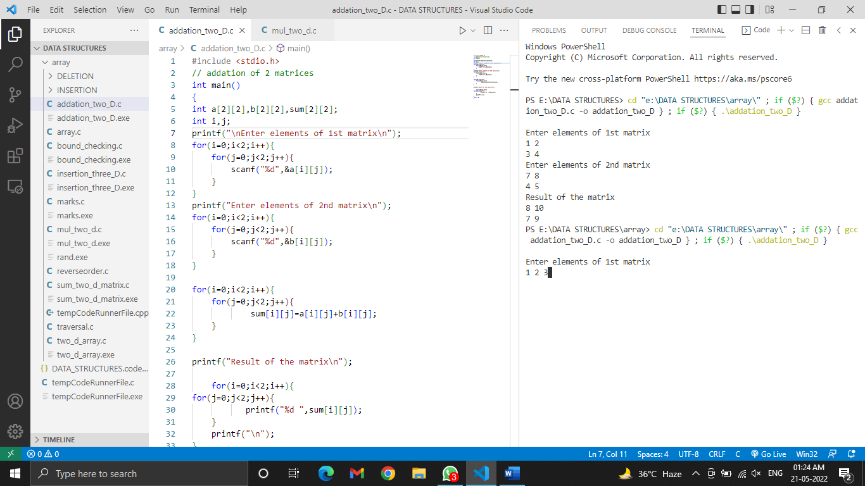

**PRACTICAL-17**

**AIM:** Write a program for multiplication of two matrix.

**PROGRAM:**

#include <stdio.h>

//multiplication of 2 matrices

int main()

{

    int i,j,k,m,n,p,q;

int a[10][10],b[10][10],res[10][10];

printf("Enter rows and columns of first matrix\n");

scanf("%d%d",&m,&n);

printf("Enter elements of first matrix\n");

for(i=0;i<m;i++){

    for(j=0;j<n;j++){

        scanf("%d",&a[i][j]);

    }

}

printf("Enter rows and columns of second matrix\n");

scanf("%d%d",&p,&q);

printf("Enter elements of second matrix\n");

for(i=0;i<p;i++){

    for(j=0;j<q;j++){

        scanf("%d",&b[i][j]);

    }

}

if(m==p){

for(i=0;i<m;i++){

    for(j=0;j<q;j++){

            int sum=0;

    for(k=0;k<m;k++){

           sum = sum + a[i][k]*b[k][j];

    }

    res[i][j]=sum;

    }

}

printf("Result after Multiplication of the  matrices are:\n");

    for(i=0;i<m;i++){

    for(j=0;j<q;j++){

           printf("%d ",res[i][j]);

}

    printf("\n");

}

}

else{

    printf("\nInvalid Matrix\n");

    printf("Colum of 1st matrix is not equal to the row of 2nd martrix");

}

}

**OUTPUT:**

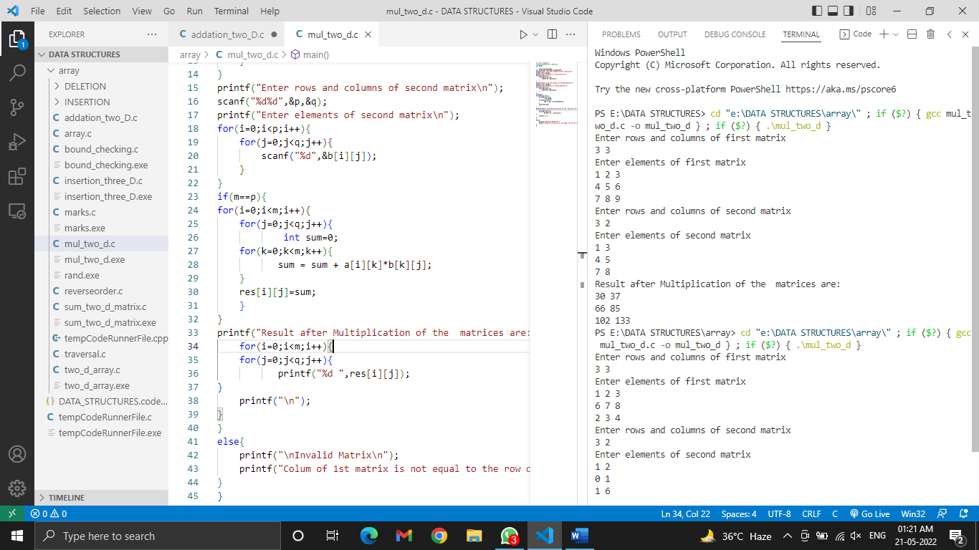

**PRACTICAL-18**

**AIM:**

**PROGRAM:**

 #include<stdio.h>

int i,j,k,num;

int main(){

    int a[2][2][2];

printf("\nEnter elements of matrix\n");

for(i=1;i<=2;i++){

    for(j=1;j<=2;j++){

            for(k=1;k<=2;k++){

        scanf("%d",&a[i][j][k]);

    }

}

}

printf("Resultant of matrix\n");

for(i=1;i<=2;i++){

    for(j=1;j<=2;j++){

            for(k=1;k<=2;k++){

        printf("%d ",a[i][j][k]);

                if(k==2)

                {

                    printf("\n");

                }

    }

}

printf("\n");

}

printf("Enter the position where you want to update:\n");

printf("Enter the block number:");

scanf("%d",&i);

printf("Enter the row number: ");

scanf("%d",&j);

printf("Enter the column number: ");

scanf("%d",&k);

printf("Enter the number you want to update with:");

scanf("%d",&num);

a[i][j][k]=num;

printf("\nMatrix after updation:\n");

for(i=1;i<=2;i++){

    for(j=1;j<=2;j++){

            for(k=1;k<=2;k++){

        printf("%d ",a[i][j][k]);

                if(k==2)

                {

                    printf("\n");

                }

       }

    }

 printf("\n");

}

return 0;

}

**OUTPUT:**

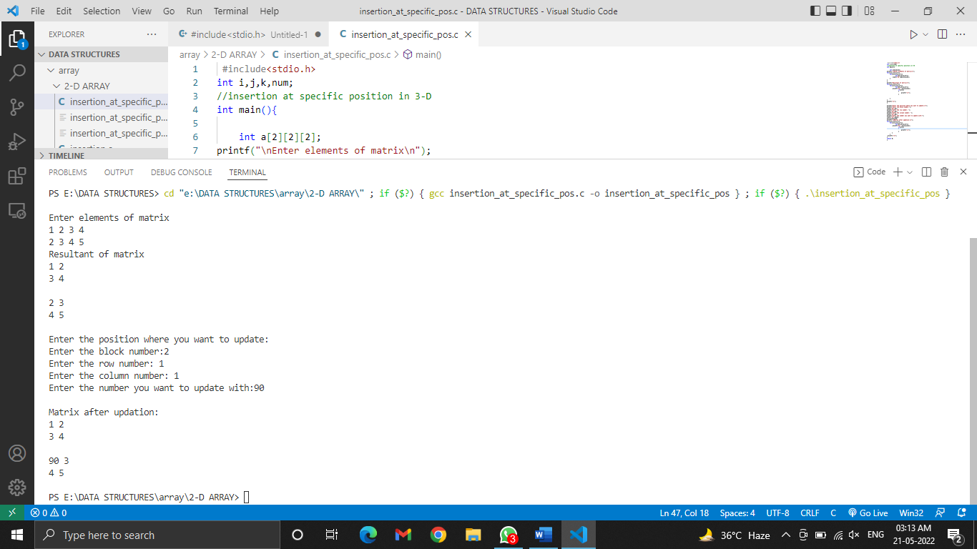

**PRACTICAL-19**

**AIM:** Write a program for Linear Search in array.

**PROGRAM:**

#include<stdio.h>

int main(){

        int i;

        int data;

        int size;

        int arr[100];

    printf("Enter the size of array:");

    scanf("%d",&size);

        printf("Enter the elements of array:");

    for(i=0;i<size;i++){

    scanf("%d",&arr[i]);}

    printf("Enter data to search for:");

    scanf("%d",&data);

        for(i=0;i<size;i++)

{

   if( arr[i]==data){

    printf("Element found at index %d:",i);

    printf("\n Found element is %d:",data);

     break;

    }

}

 if(i==size)

    printf("Element not found");

return 0;

}

**OUTPUT:**

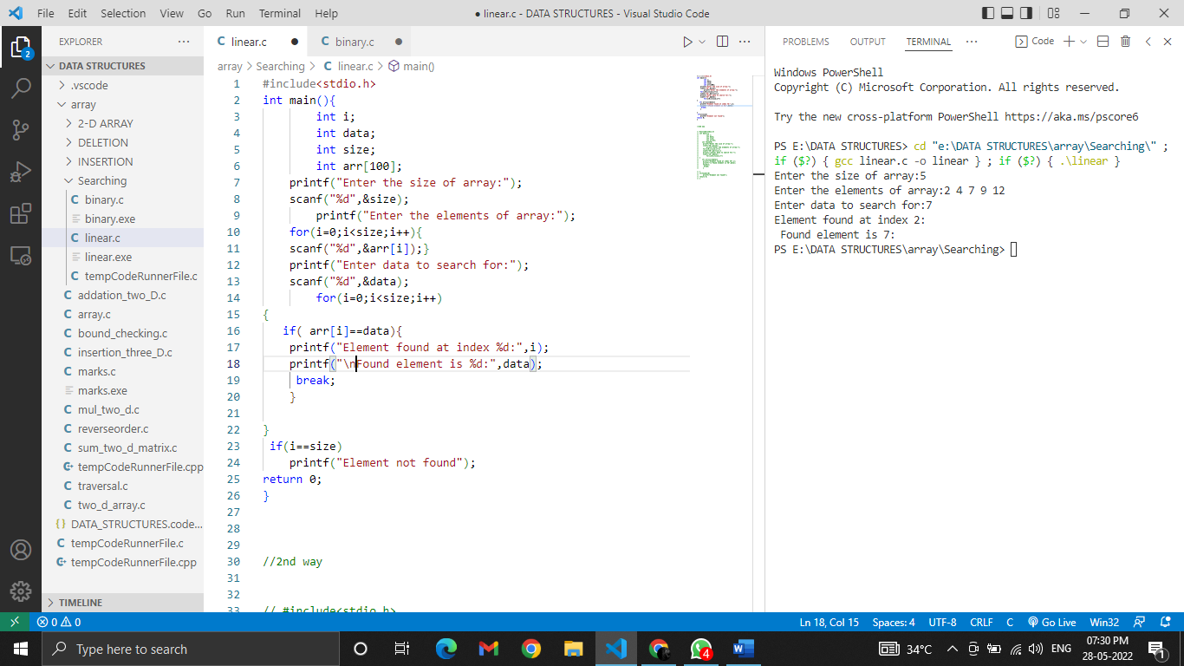

**PRACTICAL-20**

**AIM:** Write a program for Binary Search in array.

**PROGRAM:**

#include <stdio.h>

int binarySearch(int a[], int n, int data)

{

    int l = 0, r = n - 1, mid;

    while (l <= r)

    {

        mid = (l + r) / 2;

        if (data == a[mid])

        {

            return mid;

        }

        else if (data < a[mid])

        {

            r = mid - 1;

        }

        else

        {

            l = mid + 1;

        }

    }

    return -1;

}

int main()

{

    int a[50];

    int i, n, data;

    printf("Enter the size of array: ");

    scanf("%d", &n);

    printf("Enter the elements: \n");

    for (i = 0; i < n; i++)

    {

        scanf("%d", &a[i]);

    }

    printf("Enter the data you want to search \n");

    scanf("%d", &data);

    int res = binarySearch(a, n, data);

    if (res >= 0)

        printf("%d is found at index %d",data,res);

    else

        printf("Element not found!");

    return 0;

}

**OUTPUT:**

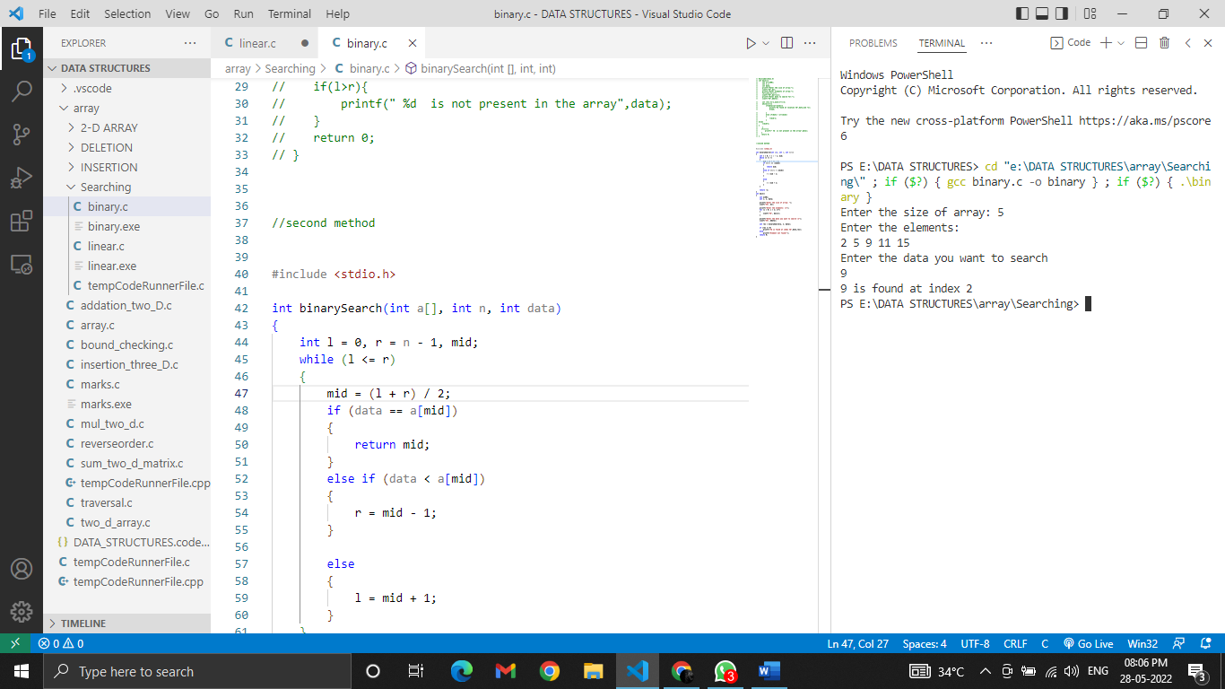

**PRACTICAL-21**

**AIM:** Write a program for Bubble Sort in array.

**PROGRAM:**

#include<stdio.h>

//bubble sort

int main(){

int i,j,temp,size,arr[100];

printf("Enter the size of array: ");

scanf("%d",&size);

printf("Enter the elements of array: ");

for(i=0;i<size;i++)

    scanf("%d",&arr[i]);

    printf("Array before implementing bubble sort\n");

 for(i=0;i<size;i++)

    printf("%d\t",arr[i]);

for(i=0;i<size-1;i++){

   int flag=0;

    for(j=0;j<size-1-i;j++){

    if(arr[j]>arr[j+1]){

        temp=arr[j];

        arr[j]=arr[j+1];

        arr[j+1]=temp;

        flag=1;

    }

}

if(flag==0)

break;

}

printf("\nArray after implementing bubble short\n");

for(j=0;j<size;j++)

printf("%d\t",arr[j]);

}

**OUTPUT:**

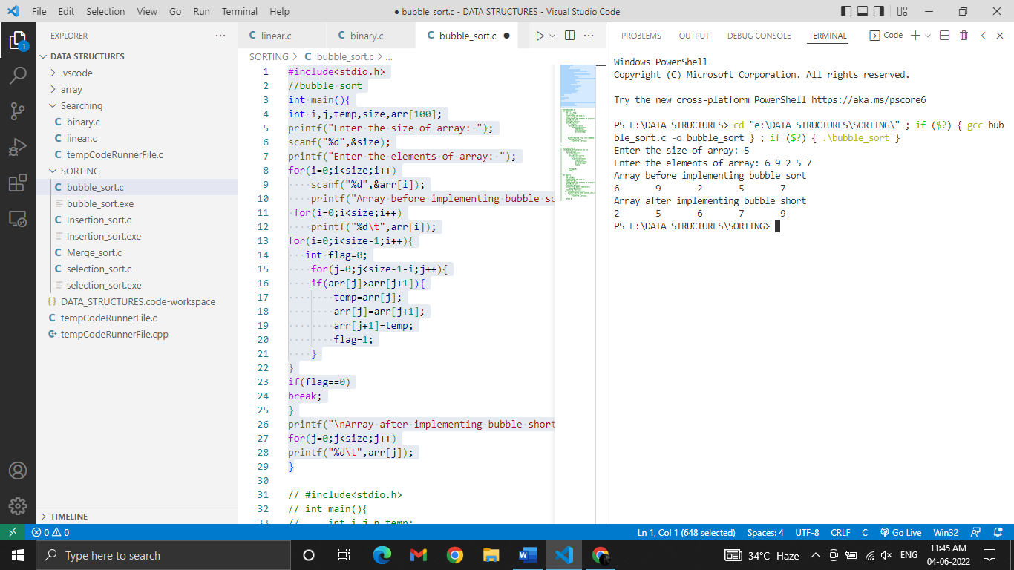

**PRACTICAL-22**

**AIM:** Write a program for Selection Sort in array.

**PROGRAM:**

#include<stdio.h>

    void selectionsort(int arr[], int size);

    void swap(int *a,int *b);

   void selectionSort(int arr[], int size)

{

    int i, j;

    for (i = 0 ;  i < size;i++)

    {

        for (j = i ; j < size; j++)

        {

            if (arr[i] > arr[j])

                swap(&arr[i], &arr[j]);

        }

    }

}

void swap(int *a, int *b)

{

    int temp;

    temp = *a;

    *a = *b;

    *b = temp;

}

 int main(){

    int i,j,size;

    int arr[50];

    printf("Enter the size:");

    scanf("%d",&size);

    printf("Enter the elements of array\n");

    for(i=0;i<size ;i++)

    scanf("%d",&arr[i]);

    printf("Array before selection sort\n");

         for(i=0;i<size;i++)

    printf("%d ",arr[i]);

    selectionSort(arr, size);

       printf("\nArray after selection sort \n");

        for(i=0;i<size;i++){

            printf("%d ",arr[i]);

        }

    return 0;

}

**OUTPUT:**

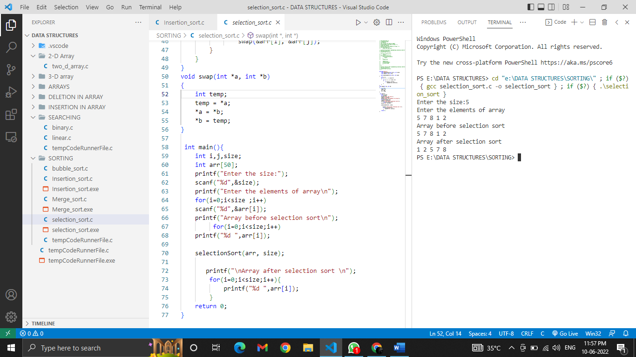

**PRACTICAL-23**

**AIM:** Write a program for Insertion sort in array.

**PROGRAM:**

#include <stdio.h>

int main()

{

    int n, i, j, temp;

    int arr[50];

    printf("Enter number of elements: ");

    scanf("%d", &n);

    printf("Enter the elements\n", n);

    for (i = 0; i < n; i++)

    {

        scanf("%d", &arr[i]);

    }

    for (i = 1 ; i <= n - 1; i++)

    {

        j = i;

            while ( j > 0 && arr[j-1] > arr[j])

            {

                temp     = arr[j];

                arr[j]   = arr[j-1];

                arr[j-1] = temp;

                j--;

            }

    }

    printf("Array after insertion sort:\n");

    for (i = 0; i <= n - 1; i++)

    {

        printf("%d ", arr[i]);

    }

    return 0;

}

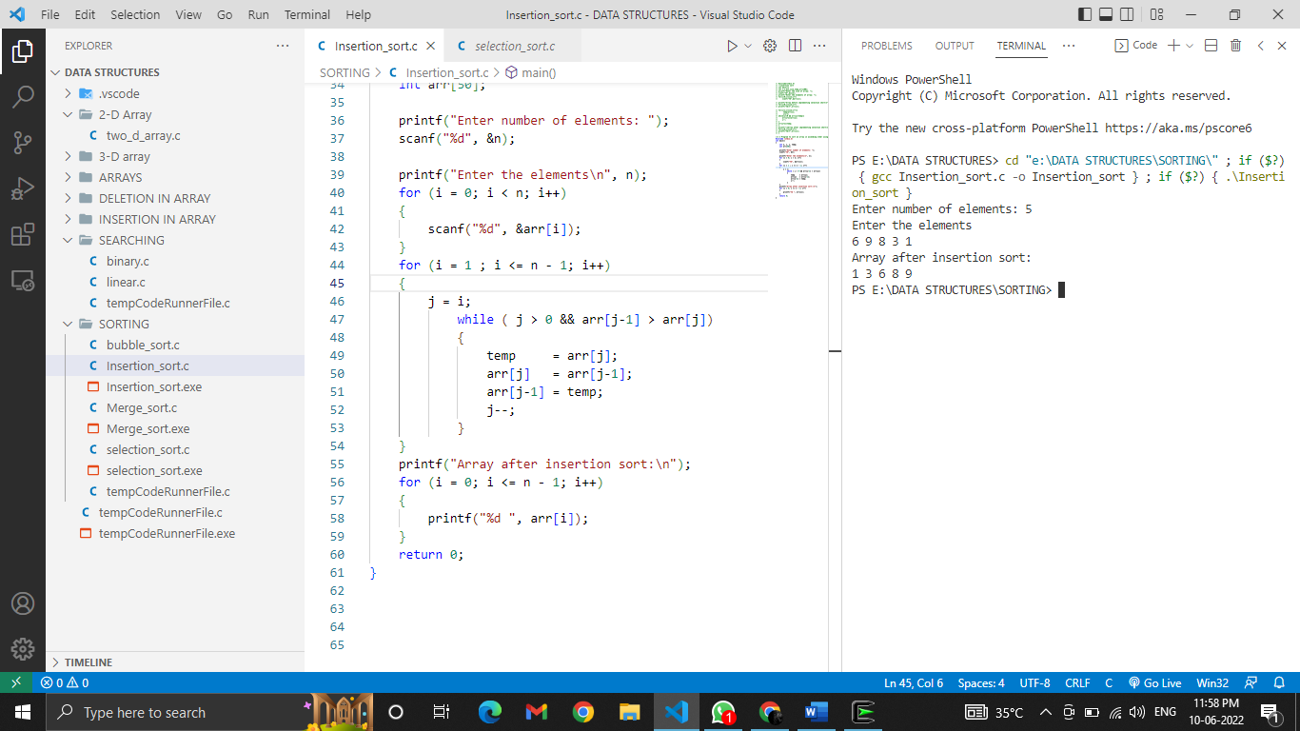**OUTPUT:**

**PRACTICAL-24**

**AIM:** WAP to insert in Linked List

**PROGRAM:**

**OUTPUT:**

**PRACTICAL-25**

**AIM:** WAP to delete a node from Linked List

**PROGRAM:**

**OUTPUT:**

**PRACTICAL-**

**AIM:**

**PROGRAM:**

**OUTPUT:**

**PRACTICAL-**

**AIM:**

**PROGRAM:**

**OUTPUT:**

**PRACTICAL-**

**AIM:**

**PROGRAM:**

**OUTPUT:**

**PRACTICAL-**

**AIM:**

**PROGRAM:**

**OUTPUT:**

**PRACTICAL-**

**AIM:**

**PROGRAM:**

**OUTPUT:**

**PRACTICAL-**

**AIM:**

**PROGRAM:**

**OUTPUT:**

**PRACTICAL-**

**AIM:**

**PROGRAM:**

**OUTPUT:**